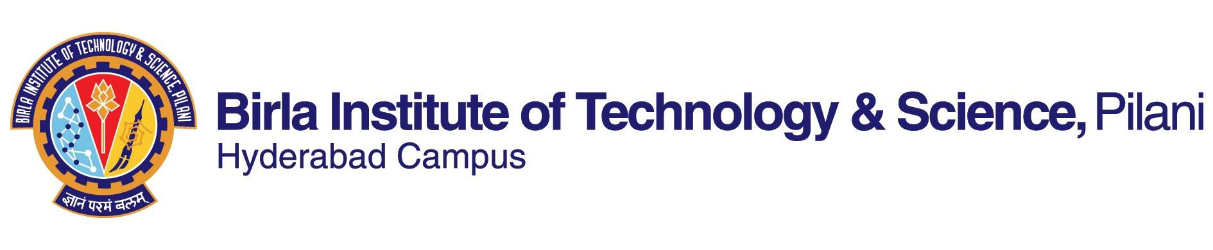

**FIRST SEMESTER 2020-2021**

# Course Handout Part II

Date: 17-08-2020

In addition to part-I (General Handout for all courses appended to the time table) this portion gives further specific details regarding the course.

*Course No.* : HSS F362

## Course Title : Local Governance and Participation

## Instructor-in-Charge : Dr. Lavanya Suresh

*Google meet link for the class*: Available on CMS

**Scope and Objective of the Course:**

Strengthening local governments is one of the most important governance challenges in India today. A strong and empowered local government can bring together inclusive growth with inclusive governance. The course will introduce students to key concepts and ideas of decentralization with a focus on the constitutional framework for the same in the Indian context. This will include understanding the 73rd and 74th Constitutional amendments; the Panchayat Extension to Scheduled Areas (PESA); the idea and impact of reservations for women, scheduled castes, scheduled tribes and other marginalized communities. State wise and sectoral case studies will be used to further engage and explain the idea of local governance and participation.

After course completion, students will be able to-

* Understand the larger political debate of devolving power to local governments
* Connect the national movement for an independent India to the ideas of direct democracy and participation
* Elaborate on means to include marginalized sections of society in policy making
* Discuss and analyze constitutional change and policy decisions that make government more accountable
* Analyse the challenges in participation of the common man in public policy and governance

**Textbooks (TB):**

Raghunandan, T R (eds.) (2012). *Decentralisation and Local Governments: The Indian Experience*. New Delhi: Orient Blackswan Private Limited.

**Reference books**

1. Jodhka (2002) Nation and Village Images of Rural India in Gandhi, Nehru and Ambedkar, EPW
2. Sivaramakrishnan (2013) Revisiting the 74th Constitutional Amendment for Better Metropolitan Governance, EPW, vol xlviII no 13, Pg 89-97
3. Gandhi, M.K. (1959) Panchayat Raj. Compiled by : R. K. Prabhu. Link : <http://www.mkgandhi.org/ebks/panchayat_raj.pdf>
4. Crook, Richard and James Manor (2000) ‘Democratic Decentralization’, OED Working, Paper No. 11, Washington, DC: World Bank

**Course Plan:**

|  |  |  |  |
| --- | --- | --- | --- |
| **Lecture No.** | **Learning objectives** | **Topics to be covered** | **Chapter in the Text Book** |
| 1-4 | To understand the political role of panchayat raj | Decentralisation below state level | Chapter 2 |
| 5-7 | Decentralized planning | Chapter 3 |
| 8-10 | Panchayati Raj Bills, Acts and Constitutional amendments, Grassroots politics | Chapter 4 |
| 11-13 | To examine inclusiveness and participation | Women in Panchayati Raj | Chapter 6 |
| 14-16 | Impact of reservation in local bodies | Chapter 14 |
| 17-20 | Local democracy and clientelism | Chapter 23 |
| 21-24 | To discuss functional and financial devolution | Fiscal decentralisation to the sub-state level governments | Chapter 17 and ref. |
| 25-27 | Functional devolution to local bodies | Chapter 18  And ref. |
| 28-30 | Federalism, urban decentralisation and citizen participation | Chapter 16 |
| 31-33 | Poverty alleviation and efforts of panchayats | Chapter 11 |
| 34-36 | To elaborate on the challenges and prospects of local government and participation | Neighborhood associations and local democracy | Chapter 19 |
| 37-39 | Law of two-child norm in Panchayat | Chapter 15 |
| 40-42 | Beyond feminine public altruism | Chapter 25 |

**Evaluation Scheme:**

|  |  |  |  |  |
| --- | --- | --- | --- | --- |
| **Component** | **Duration** | **Weightage (%)** | **Date & Time** | **Nature of Component** |
| Test 1 | 30 min. | 15 | September 10 –September 20 (During scheduled class hour) | Open Book |
| Test 2 | 30 min. | 15 | October 09 –October 20 (During scheduled class hour) | Open Book |
| Assignment | - | 20 | Completed by Third Week of October | Open Book |
| Test 3 | 30 min. | 15 | November 10 – November 20 (During scheduled class hour) | Open Book |
| Comprehensive Examination | 120 minutes | 35 | As announced in the Timetable | Open Book |

**Chamber Consultation Hour:** A Google Meet link along with consultation hours will be shared on the CMS.

**Notices:** Notices will be displayed **only** on CMS

**Make-up:** The make-up for an evaluation component will be given only in genuine cases with documentary proof.

**Academic Honesty and Integrity Policy**: Academic honesty and integrity are to be maintained by all the students throughout the semester and no type of academic dishonesty is acceptable

**Dr. Lavanya Suresh**

**INSTRUCTOR-IN-CHARGE**